BluSynergy Springboot Assessment
Context
We wish to create a very simple order management system, similar to a shopping cart model that is found on a typical consumer website.
Domain Objects and their properties:
- Customer.
Properties: name (varchar 50), email (varchar 100); One customer may have many orders. The customer is created along with the Order, so no separate screens are required.
- Products.
Properties: Name (varchar 20), Description (varchar 100), Price (decimal); You may pre-populate the products at application initialization (i.e., no screens required for product management)
- Order:
Properties: [You decide what properties are needed based on the diagram and requirements]. One order can have many Products and is obviously associated with a single customer.

Screen
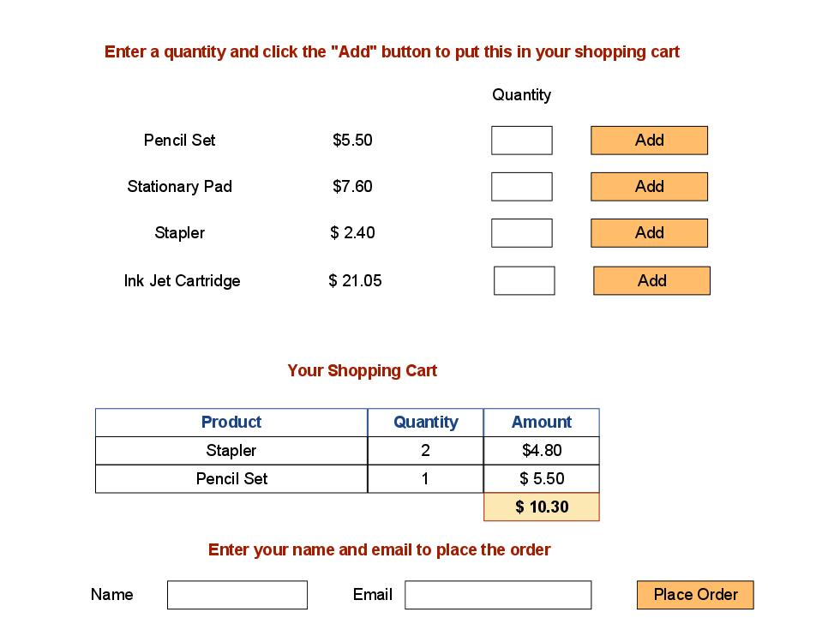
Create a single screen that allows a user to:
- View the list of available products with price information. (This list of Products has been pre-populated in the DB during application startup)
- Select the products they wish to order along with the quantity. They do this by entering the quantity and clicking the "Add" button.
- When the "Add" button is clicked, the Product is now put in the shopping cart and the web page is updated to show the new item in the shopping cart. No Order is to be created at this point. They may add multiple Products. Note that the Total in the shopping cart table must be updated.
- Finally the user enters their name and email, and clicks the "Place Order" button. At this point, a new Order and a new Customer record are created. All fields must be validated (for example, the length specified is not exceeded).
- Finally, display a confirmation page to the user showing them the items they have purchased along with the total amount.

